Stage 6 – "I'm dropping the hammer!"
COURSE DESIGNER: Ike Starnes
SCORING: Comstock 24 rounds.
TARGETS: 12 cardboard targets
SCORED HITS: 2 Best hits per carboard will be scored.

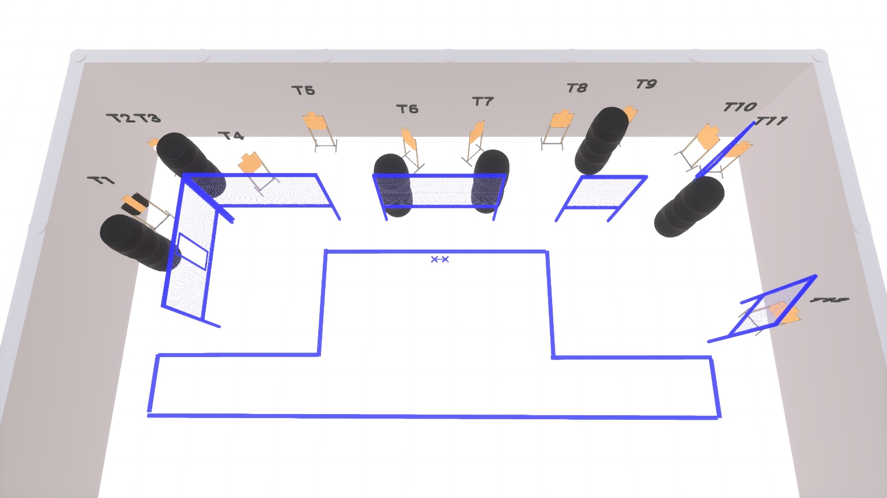

Written Stage Briefing:

Stage 6 – "I'm dropping the hammer!" - is a 24 round, 120 point, Comstock Course. There are 12 cardboard targets.

Starting with both feet on XX’s.
Handgun is loaded and holstered, wrists below belt.
PCC loaded, held in both hands, stock touching belt.

On the audible start signal, engage targets from within the shooting area.

USPSA / NROI Range Commands:
- Make Ready
- Are you ready?
- Standby
- If finished, unload and show clear
- If clear, hammer down and holster (Handgun)
If clear, hammer down and flag (PCC)
If clear, cylinder closed and holster (Revolver)
- Range is clear

Setup Notes:
10 Single Wall Stands
1 Double Wall Stands
3 Full Walls
2 Half Walls
1 Port Walls
12 Target stands / 24 target sticks
12+ Barrels



